

**Collaboration Project**

**(Database Management System, Web Development, Management Information Systems)**

**E-Commerce System**

**By:**

**3R1**

**Submitted to:**

**Ma’am Petal May Dal**

**Sir Archie Pachica**

**Sir Joemar Llevado**

**Chapter 1**

**Introduction**

**1.1. Background and Rationale**

The world is now coalesced to a click on our computers. Since long ago, all materials around are still being searched for personally, we stroll through markets, travel long distances just to buy something. But now, we can now carry our shopping bag in your devices, whether it may be desktop, laptop, or mobile phones, all you need is an internet connection, and you can search your desired item anytime and anywhere.

This is the project all about, it is one of the trending methods of buying things nowadays, it is called E-Commerce. It stands for “Electronic Commerce”. It allows trading and buying goods and services through electronic mediums namely computers, or any other devices that can connect to the internet. This system involves Information Communication Technology, Electronic Funds Transfer in making commerce between consumers to organizations, organizations to organizations, and consumers to consumers.

The system has seven modules namely products, customer, order, billing, delivery, inventory and supplier management. Customer module is responsible for allowing the end user to view the products. Product module is for the manipulation of products. Order module allows the customer to purchase a product, inform the user if the chosen product is available or not, choose the mode of delivery, refund, know the delivery date, and status of delivery. Billing module is for the computations of a customer’s purchase and of the supplier’s, and mode of payment. Delivery module is for the tracking of courier and status of delivery. Inventory module is for the display of products left and supplier management for the list of suppliers and their products.

A customer can see the products in front, top and side view. When a user likes a certain product, he can click the product and add it to the cart and upon clicking the buy button, if he is a registered user, the payment and mode of delivery will be processed. If not, he will be redirected to a sign-up form. The suppliers of the products can also be seen on the site.

* 1. **Statement of the problem:**
* The problem of E-commerce nowadays has little amount of electronic products that is being sold online. In this E-Commerce we decided to exclusively sell electronic products for those customers who want electronic gadgets that have a hard time finding that specific gadget.
  1. **Objectives of The Study:**

-E-Commerce provides an easy way for customers to buy electronic products, this also helps the people narrow down their search for a specific electronic product which leads to them finalizing the product they want to buy, instead of searching on Google, or any other search engine and E-Commerce sites.

* 1. **Significance of The Study:**

Nowadays, people all around the world spend more time on the internet for work, for study, project making, marketing, business, and even learning. All these activities are connected to the internet, so it is impossible if we don’t implement E-Commerce system in this, that is why it is important to have this nowadays.

**1.5. Scope and Limitations:**

* The project is only limited to electronic products, customers can only buy, and suppliers can only view products requested by the admin.

**Chapter 2  
REVIEW OF RELATED LITERATURE**

# 2.1 The End of E-Commerce as we know it Ms. [Janette Toral](https://digitalfilipino.com/author/janette-toral/) (February 2013) in an article titled “The End of E-Commerce as we know it” stated that “I think the lack of a reliable industry figure on how e-commerce is growing in our country is hurting us. It puts our country in a bad light and not an attractive destination for e-commerce. ”. According to her, although there are e-commerce players in the Philippines who are performing well in revenue performance, the lack of a fixed point or definition on how the e-commerce industry is defined in the country will have a negative effect on the industry in the long run. The solution Ms. Toral sees for this problem is the establishment of a e-commerce framework in order to properly define and support the industry.

**2.2 The future and challenges of e-commerce in the Philippines**

# Mr. Al Gomez (September 2015) in an article titled “The future and challenges of e-commerce in the Philippines” discussed that the Philippines is still a developing country and that e-commerce is still in its infancy. But the characteristic of Filipinos to quickly adapt to newly introduced technologies brings an advantage to the e-commerce industry as Filipinos are beginning to favor it more than traditional commerce and investors for online markets are quickly noticing his trend and are already investing in the online market industry. Mr Gomez also stated the Filipinos are a competent and reliable force in which the traits of being hard working, efficient, self-learn, depend on their own skills and resources can be beneficial for businesses in the e-commerce industry. But the challenge that hinder the industry from prospering is the lack of access or acquisition of newer technologies such as a strong internet connection. Even though Filipinos are able to adapt, be skillful and efficient and be even a leading force in using the social media platforms, without proper technological improvements on utilities such as proper internet connection and cooperation between key players and the government, the e-commerce industry may only develop slowly, if not, may only remain as to where it is now and never improve until these obstacles are addressed.

**Chapter 3**

**Methodology**

**A. Business Rules**

1. Customers who are not registered can only view products on the Homepage.

2. Customer must register first to process transaction/s.

3. Customer must first log in to order products.

4. Supplier must be registered to supply stocks.

5. Courier must be registered to deliver orders.

6. A customer may have zero or many orders.

7. An order can have many products.

8. Products can be ordered by many customers.

9. An order can only have one billing.

10. A billing can only have one order.

11. A billing can only have one type of payment.

12. One courier can have zero or many deliveries.

13. One delivery can have one or many orders.

14. Orders can be made without making a delivery.

15. Products can be supplied by many suppliers

**B. Entity Relationship Diagram**

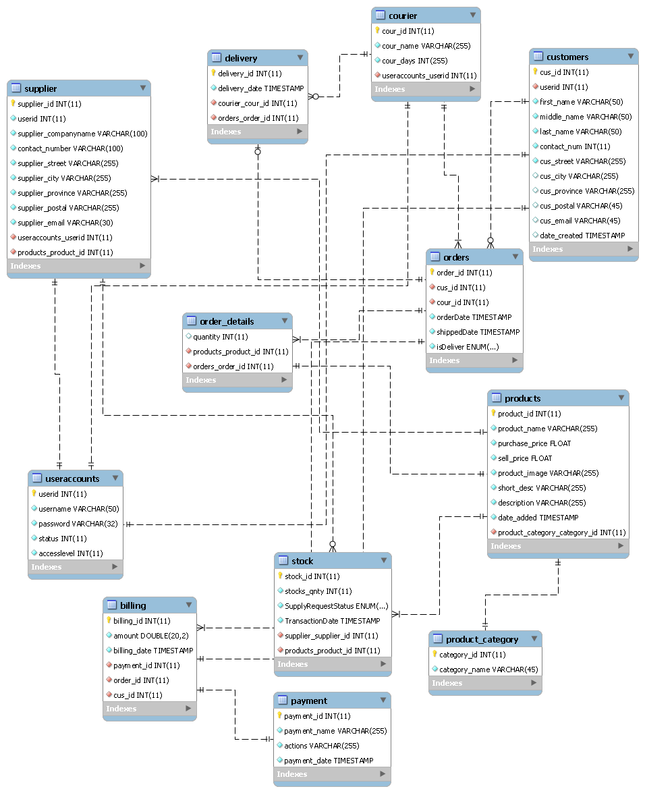

Chapter 4

**Project Making**

**Pictures**

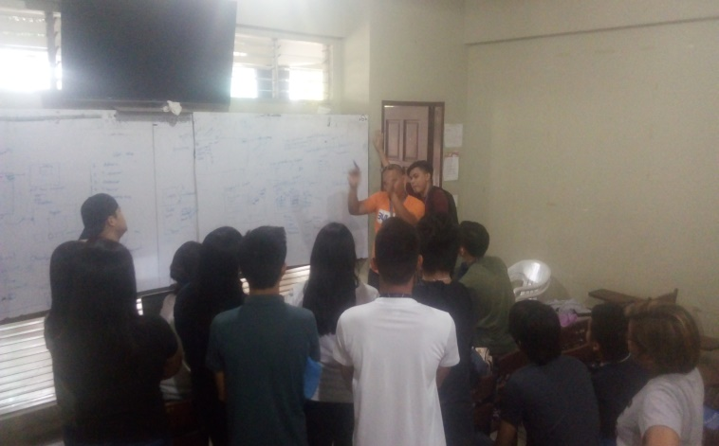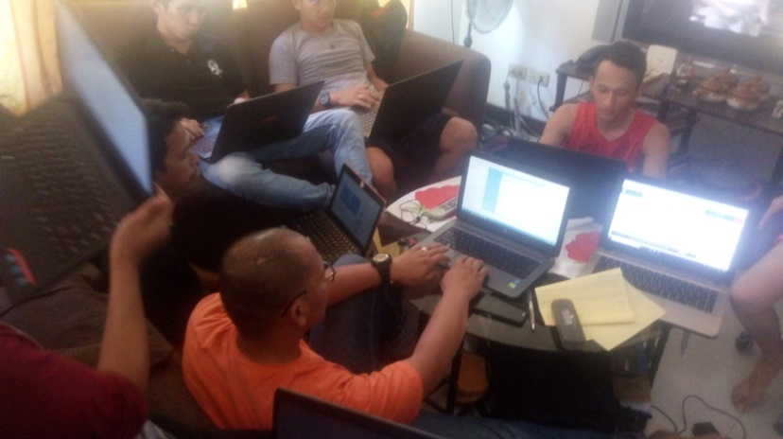

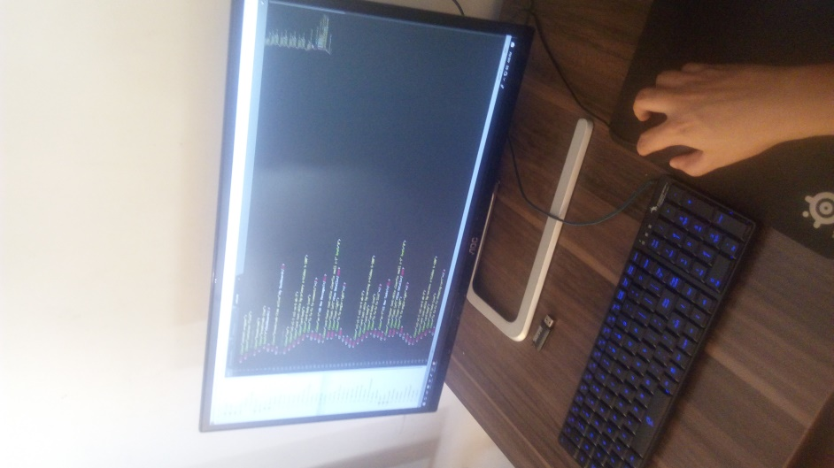

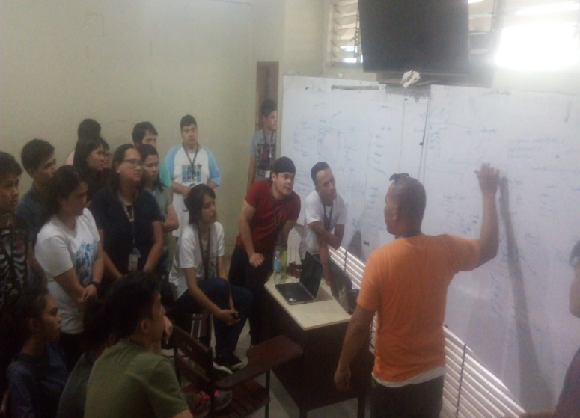

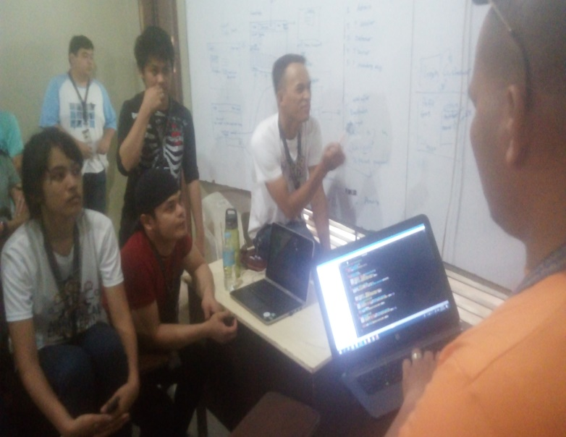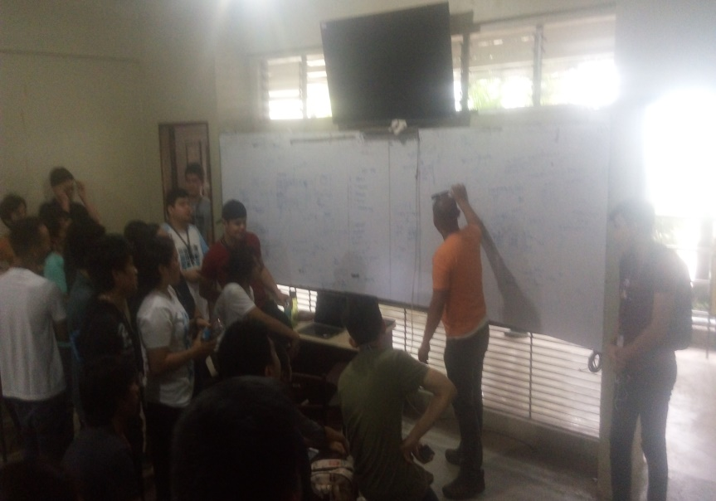

**Bibliography/References**

**1] S. Shahrzad, M. Shadriari, and S. Gheiji, “E-commerce and its**

**impacts on global trend and market”**

**Vol.3, April, 2015. International Journal of Research**

**Granthaalayah, pp.49-55**

**2] I. Apulu, and A. Latham, “Information and communication**

**technology adoption:Challenges for Nigerian SMEs”, 4(2),**

**2009.TMC Academic Journal, pp. 64-80.**

**3] H. Ongori, “Role of Information Communication**

**Technologies Adoption in**

**SMEs: Evidence from Botswana”, Vol.1 (2), 2009, Research**

**Journal of Information Technology, pp.79-85.**

**4] C. Peters, and C.D. Bodkin, “An exploratory investigation of**

**problematic online auction behaviors: Experiences of eBay**

**users” Vol. 14(1), 2007, Journal of Retailing & Consumer**

**Services, pp. 1-16.**

**5] A. Obayi, (2013) “CIT415 Introduction to E-Commerce”.**

**National Open University of**

**Nigeria. ISBN: 978-058-184-7, First Printed 2013.**

**C. Data Dictionary**

**Table Billing**

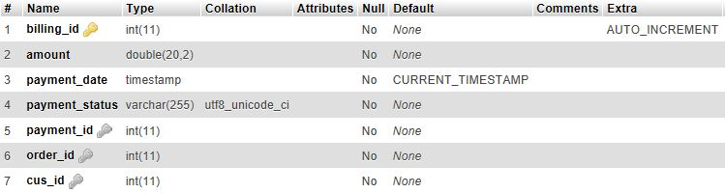

**Table Category**

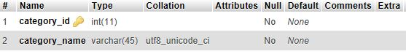

**Table Courier**

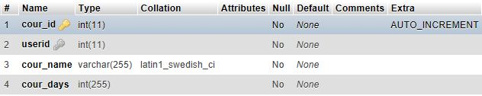

**Table Delivery**

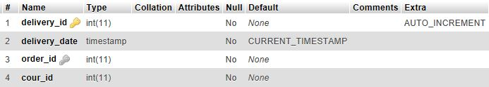

**Table Payment**

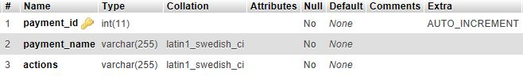

**Table Order**

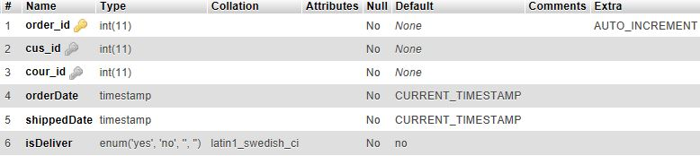

**Table Order Details**

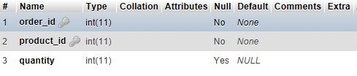

**Table Product**

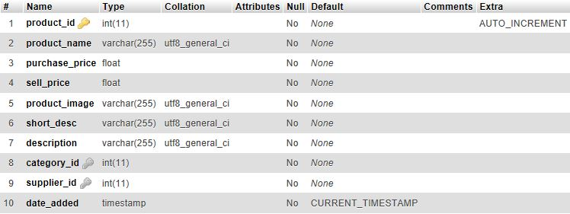

**Table Customer**

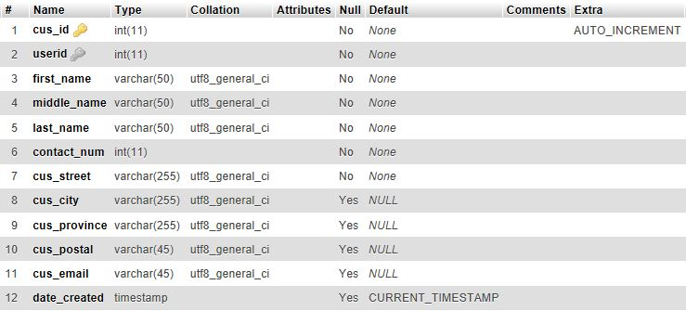

**Table Stock**

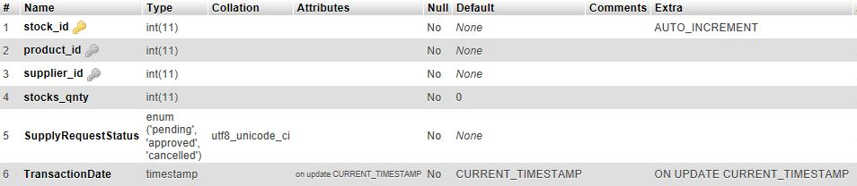

**Table Supplier**

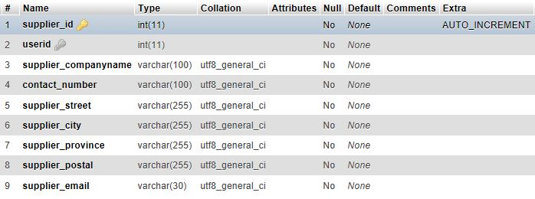

**Table Useraccounts**

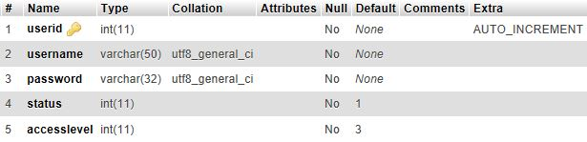

Chapter 5

**Conclusions and Discussions**

**5.1 Group Discussion**

The project can still be improved due to the fast evolution of technology in this generation we are living. As we discussed about our project we found out that there are some parts that we can still further improve. But due to the large number of members we have we are unable to communicate well because of the broad ideas everybody is contributing. All of the ideas are positive but not all are easy to implement. So we settled on making a project that is simple, efficient and meets only the core functionality of the system.

**5.2 Conclusion**

We have concluded that making a system like this is not easy, also with the vast number of people that’s contributing to the project it is hard to finalize the system’s idea in design, database, and procedures. So what we did was we gathered the assigned module leaders and generated the best idea to settle down with.